1. Start Jenkins Dashboard.

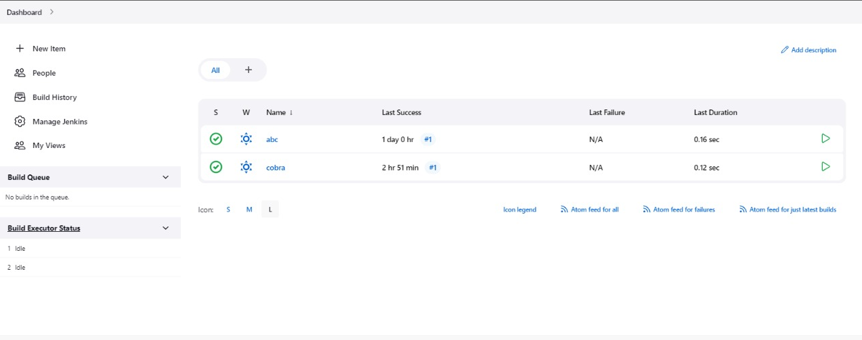

1. Go to Manage Jenkins

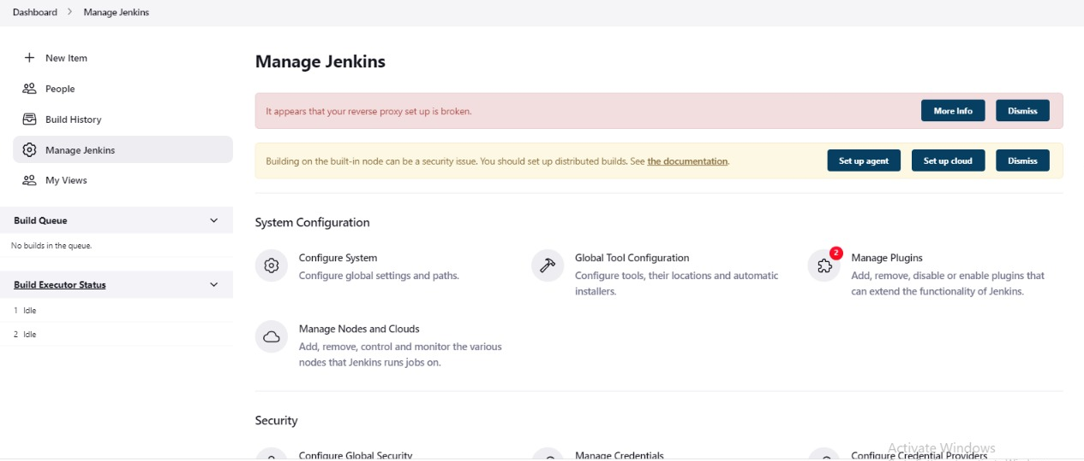

1. Go to user management

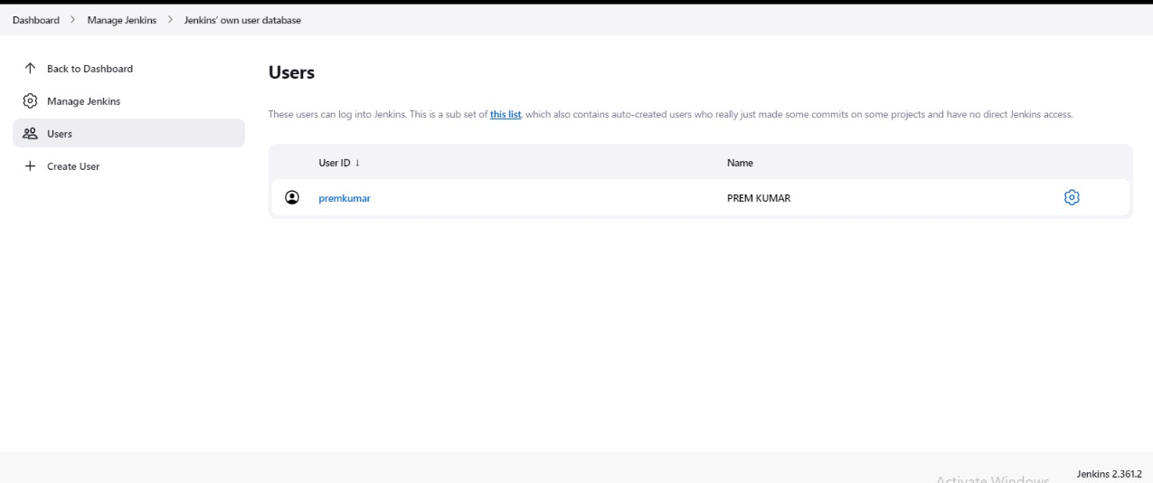

1. Create two users with the names Bob and Alice





1. Go to Global Security and add Matrix-based & project-based authorization to Bob & Alice

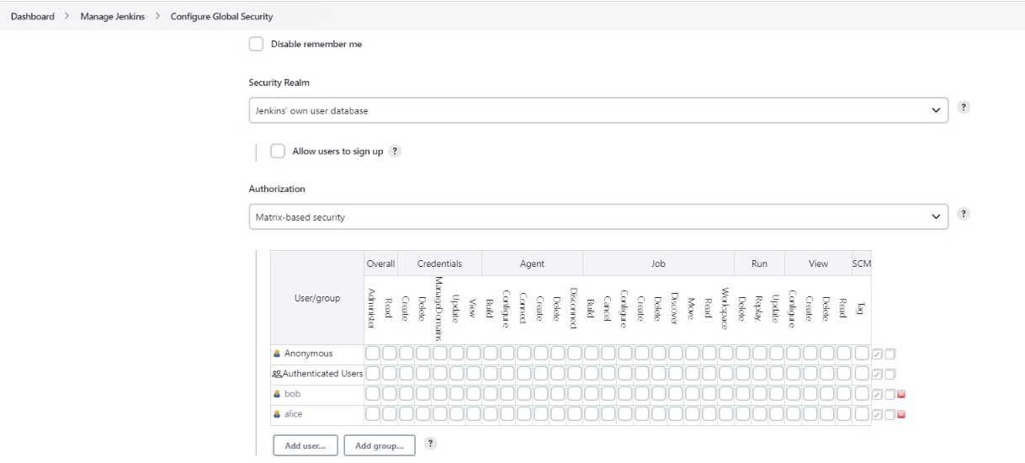

6. Bob should have permission to read all jobs only

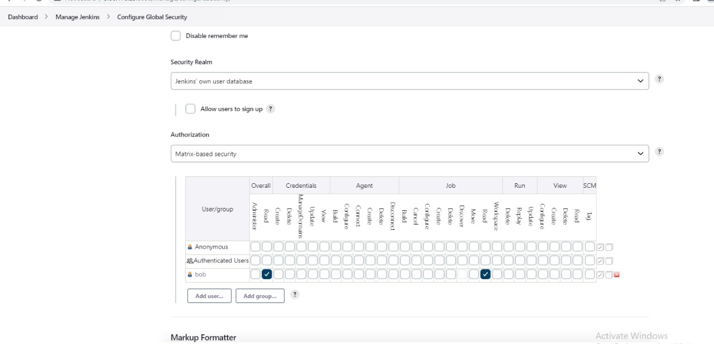

7. Alice should have permission to read all the jobs and build only a particular job.

